Team 1 Open Source Air Quality Monitoring

Week 20: May 22 - May 29

Sponsor: Dr. [David Burnett](mailto:dburnett@pdx.edu)

Advisor: Dr. John Acken

Team Members: [Adam Dezay](mailto:adezay@pdx.edu), [Manuel Garcia](mailto:manga2@pdx.edu), [Brandon Hippe](mailto:bhippe@pdx.edu), Mercedes Newton

**Team Review:**

* Team began working on a rough draft of the final report as well as an academic report per Dr. Burnett’s suggestion
* Team is writing a website to show our work then adding a QR code to our final poster that links to that. We hope to get it hosted by the university.
* Building the last 2 enclosures and soldering the last nodes
* Working on having 2 working final nodes to present on Thursday to Dr. Burnett

**Individual Review**

Adam Dezay:

Almost finished with the first draft of a website. Still need to figure out how to get it hosted on the university’s website. Finishing up the draft of the final report. Updating Github.

Manuel Garcia:

Built 2 more PCBs, finished modifications of PCBs and made changes to existing ones. Order and built batter supply modules, and tested them with our ful built circuit. Prepared test setup for week 20 demo

Brandon Hippe:

Continued to work on ironing out hardware issues, graphing script, and power testing. Planning to work on demo builds this week and cleaning up GitHub.

Mercedes Newton:

Began documentation process and transferred team documentation to final report in LaTex. Soldered and modified PCB boards.

**Gantt Chart and Timeline Updates:**

Below is both the timeline of the projected project progress for spring term. Figure 1 represents the gantt chart for the term with expected completion dates beginning March 25th. All specific dates for the upcoming term are specified in the table below.

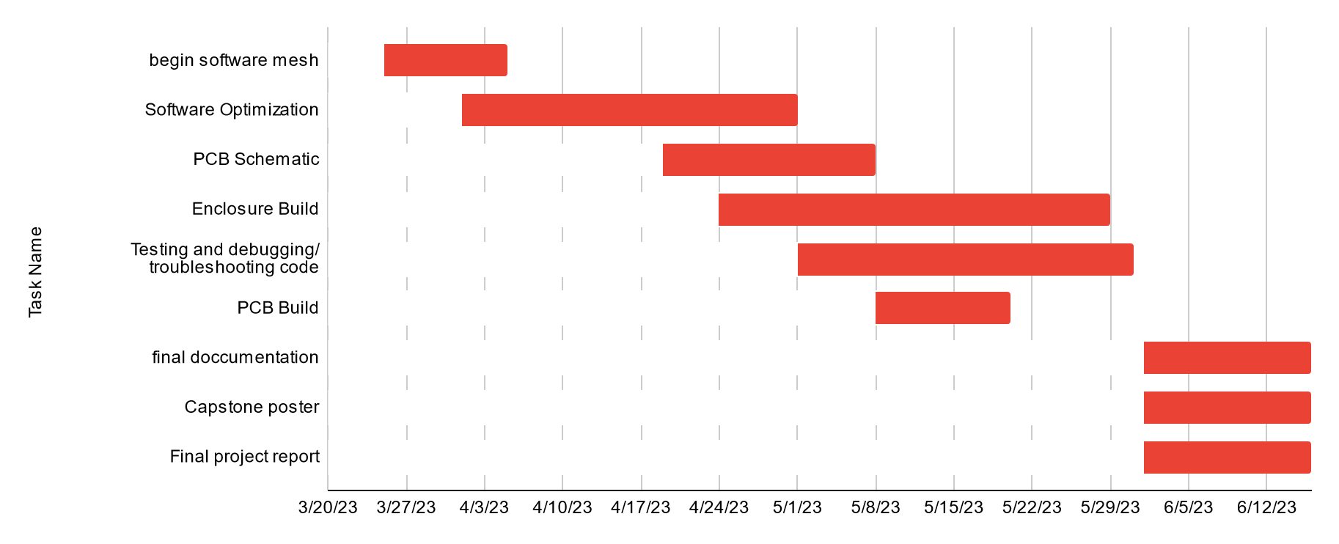

Figure One: Gantt chart for spring term (first task starts 3/25/2013)

| Task Name | Start date | End date |
| --- | --- | --- |
| Begin software mesh | 3/25/2023 | 4/5/2023 |
| Software Optimization | 4/1/2023 | 5/1/2023 |
| PCB Schematic | 4/19/2023 | 5/8/2023 |
| Enclosure Build | 4/24/2023 | 5/29/2023 |
| Testing and debugging/ troubleshooting code | 5/1/2023 | 5/31/2023 |
| PCB Build | 5/8/2023 | 5/20/2023 |
| final documentation | 6/1/2023 | 6/16/2023 |
| Capstone poster | 6/1/2023 | 6/16/2023 |
| Final project report | 6/1/2023 | 6/16/2023 |